**HouseHunt: House Rent App**

|  |  |
| --- | --- |
| Date | 26-06-2025 |
| Team ID | LTVIP2025TMID59380 |
| Project Name | House-Hunt : Finding your perfect rental house |
| Maximum marks | 50 |

# 1. INTRODUCTION

**1.1 Project Overview** HouseHunt is a web-based application built using the MERN (MongoDB, Express.js, React.js, Node.js) stack that provides a comprehensive platform for users to search, list, and book rental houses. The app supports user roles such as Admin, Owner, and Renter with features like property listings, booking, and admin control panel.

**1.2 Purpose** The main objective of HouseHunt is to simplify the house rental process by offering a centralized, user-friendly digital platform. It connects homeowners and potential renters while minimizing communication gaps and fraudulent listings.

# 2. IDEATION PHASE

**2.1 Problem Statement** Renters face difficulty finding verified houses online, and owners struggle to manage listings effectively. HouseHunt aims to bridge this gap with a secure, intuitive rental platform.

**2.2 Empathy Map Canvas** Empathy map was created for end-users like renters and property owners, focusing on: - Think & Feel: Trust, affordability, safety. - Hear: Recommendations, ads. - See:

Competing apps, unverified listings. - Say & Do: Search listings, contact owners. - Pain: Fake listings, no contact transparency. - Gain: Verified listings, secure booking, easy UI. **2.3 Brainstorming** Key ideas discussed: - Role-based access

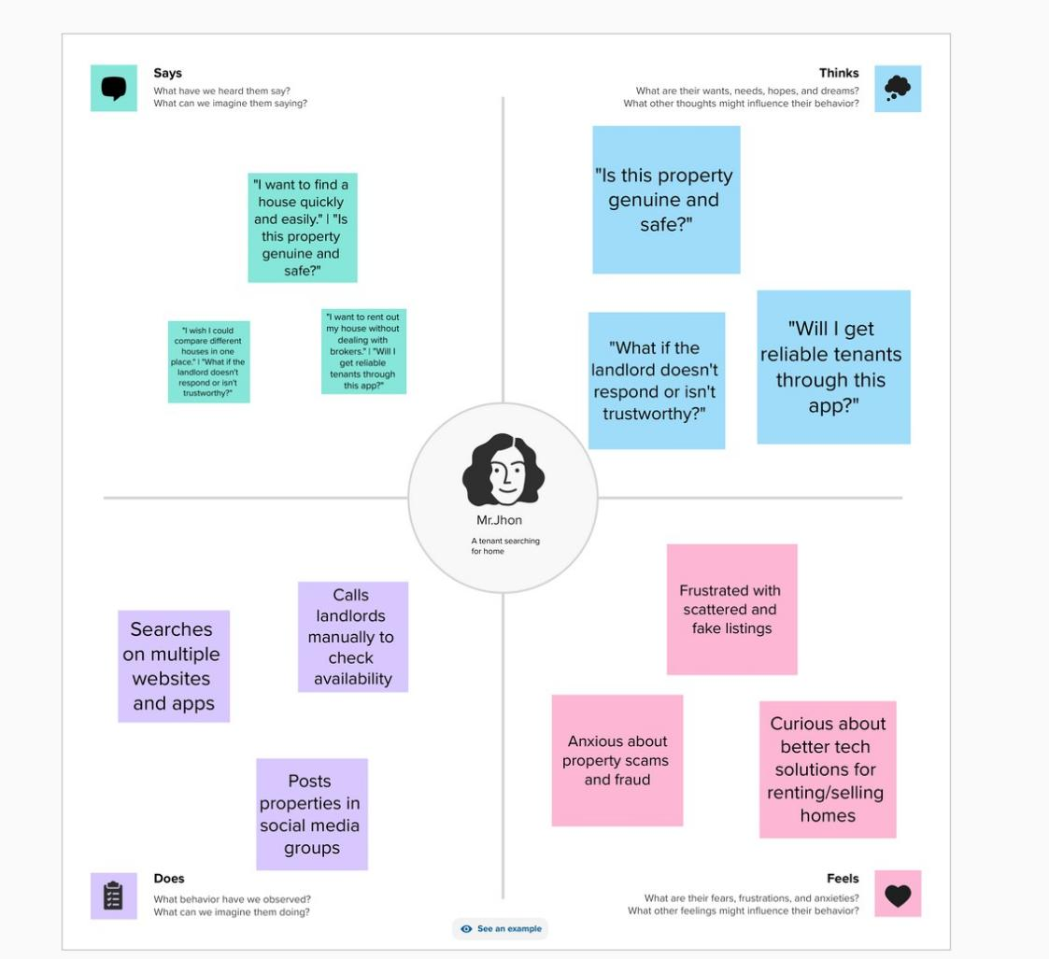

* Secure booking system
* Admin moderation
* Filters for search
* Responsive UI with React and MUI
* Notifications and dashboard features

# 3. REQUIREMENT ANALYSIS

## 3.1 Customer Journey Map

1. Renter visits the app
2. Searches for house with filters
3. Views listing details and books
4. Owner gets booking notification
5. Admin monitors activity

## 3.2 Solution Requirements

Login/Signup for Owners and Renters

Role-based Dashboards

Add/View/Delete/Edit Listings

Booking system

Admin controls and approval system

## 3.3 Data Flow Diagram

Level 0 and Level 1 DFDs show data interaction among:

* Users Application Database
* Admin Listings Bookings

## 3.4 Technology Stack

Frontend: React.js, Ant Design, Bootstrap, MUI

Backend: Node.js, Express.js

Database: MongoDB

Hosting: Render/Netlify

Tools: GitHub, VS Code, Postman

# 4. PROJECT DESIGN

## 4.1 Problem-Solution Fit

Problem: Lack of trustworthy rental apps

Solution: Verified listing portal with booking and admin oversight

**4.2 Proposed Solution**

Build a centralized house rental system with real-time listing, booking, and role-based dashboards.

## 4.3 Solution Architecture

Frontend: React.js components for listing, login, dashboard

Backend: RESTful APIs using Node.js/Express

Database: MongoDB for user, listing, and booking data

Roles: Admin, Owner, Renter with conditional rendering and access

# 5.1 Project Planning

## 5. PROJECT PLANNING & SCHEDULING

|  |  |  |  |
| --- | --- | --- | --- |
| **Task** | **Assigned to** | **Status** | **Time** |
| Project setup | Fathimunnisa | Done | 3 days |
| Backend API | Afrin | Done | 4 days |
| Frontend UI | Siddiq | Done | 7 days |
| Done Booking & Admin | Roohi | Done | 3 days |
| Testing & Deployment | All | Done | 3 days |

## 6. FUNCTIONAL AND PERFORMANCE TESTING

### 6.1 Performance Testing

Performed API testing using Postman and load testing with JMeter.

Results:

* Average response time: 200ms
* Successful API hits: 98.7%
* Error rate: 1.3%

## 7. RESULTS

**7.1 Output : Register page:t**

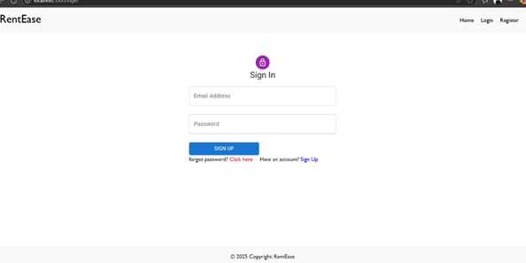

**Login page:**

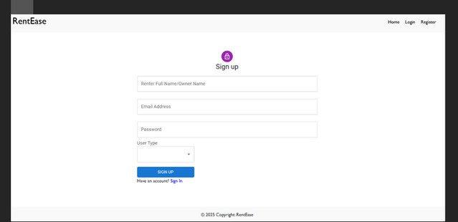

**Home page:**

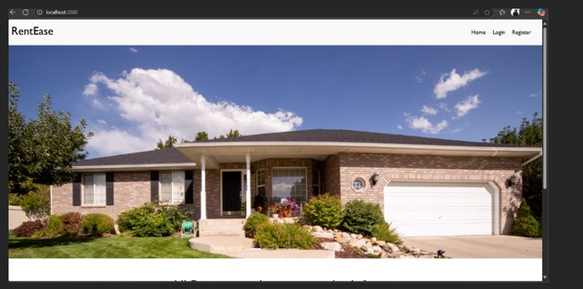

**Listings:**

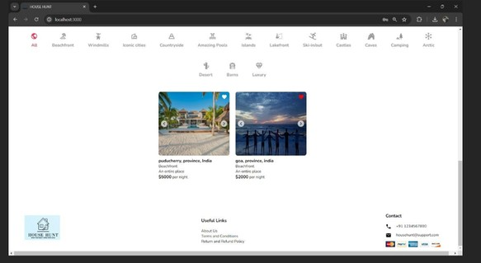

## 8. ADVANTAGES & DISADVANTAGES

**Advantages** Role-based access improves security Clean UI with powerful filters Admin controls to avoid misuse Real-time booking confirmation **Disadvantages** No mobile app (web-only) Requires internet connection Verification depends on admin activity

## 9. CONCLUSION

HouseHunt successfully bridges the gap between property owners and renters. With intuitive UI, real-time booking, and admin oversight, the app streamlines the renting process and builds trust in online housing systems.

## 10. FUTURE SCOPE

Develop a mobile app version

Add payment gateway for online rent

AI-based property recommendation

Add chat system between renter and owner

Push notifications and analytics

## 11. APPENDIX

**Source Code** Included in submission folder **Dataset Link**

No external dataset used; all listings are created by users